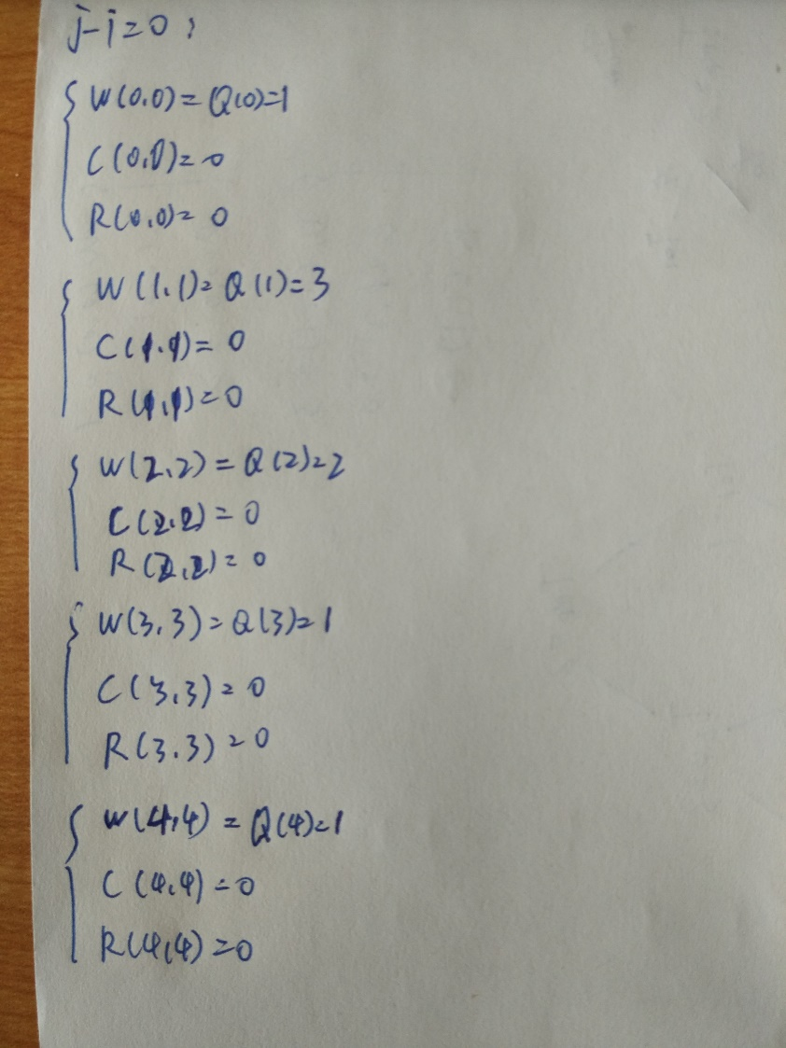

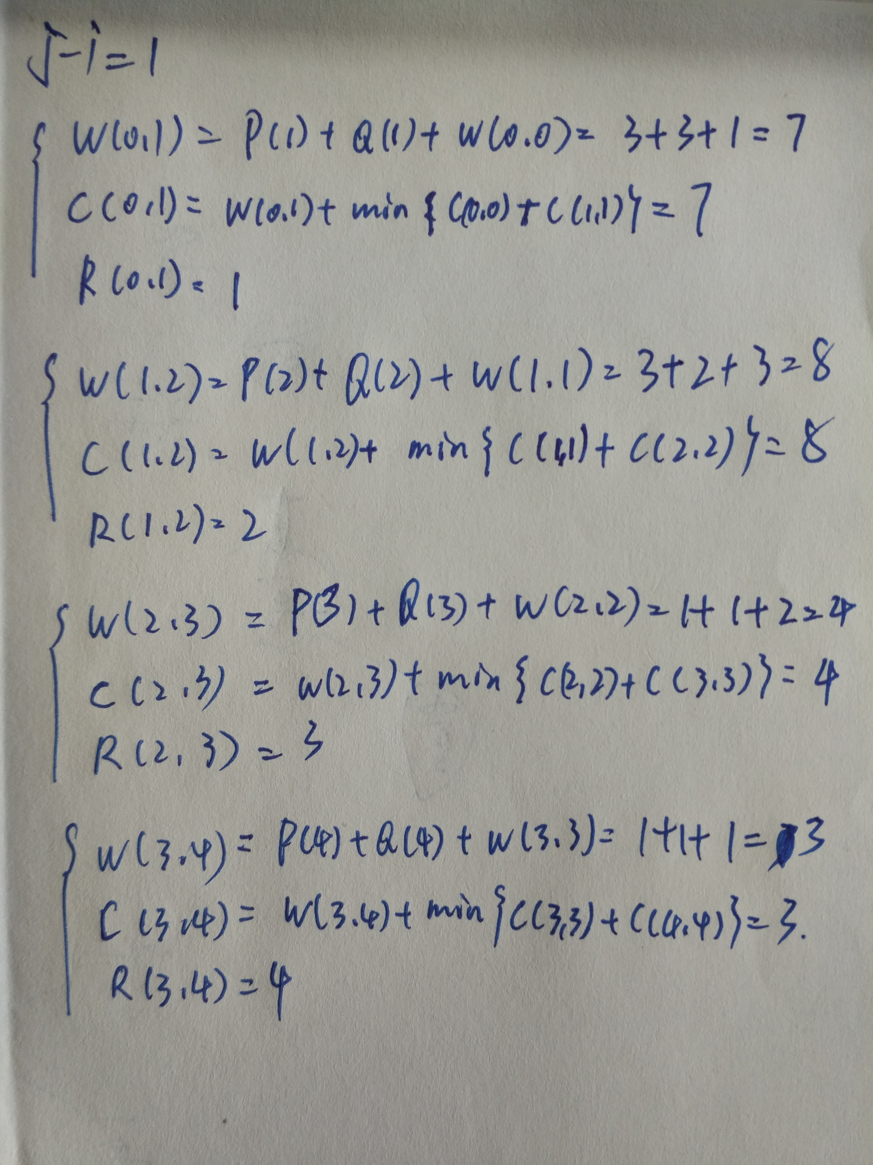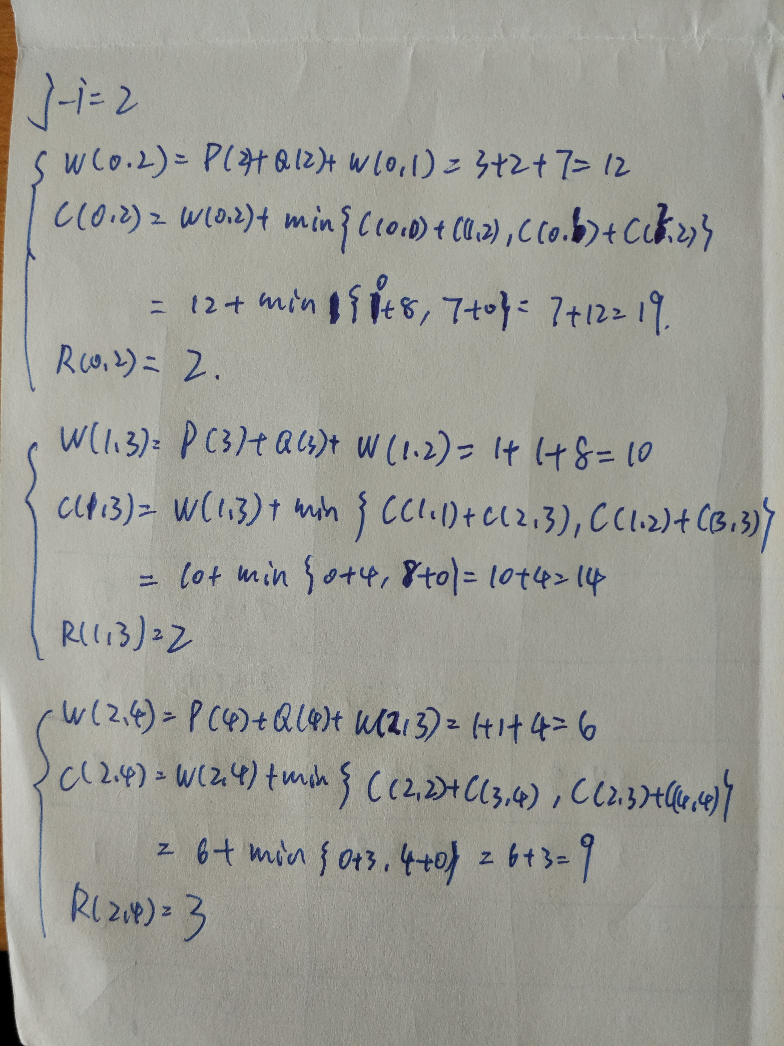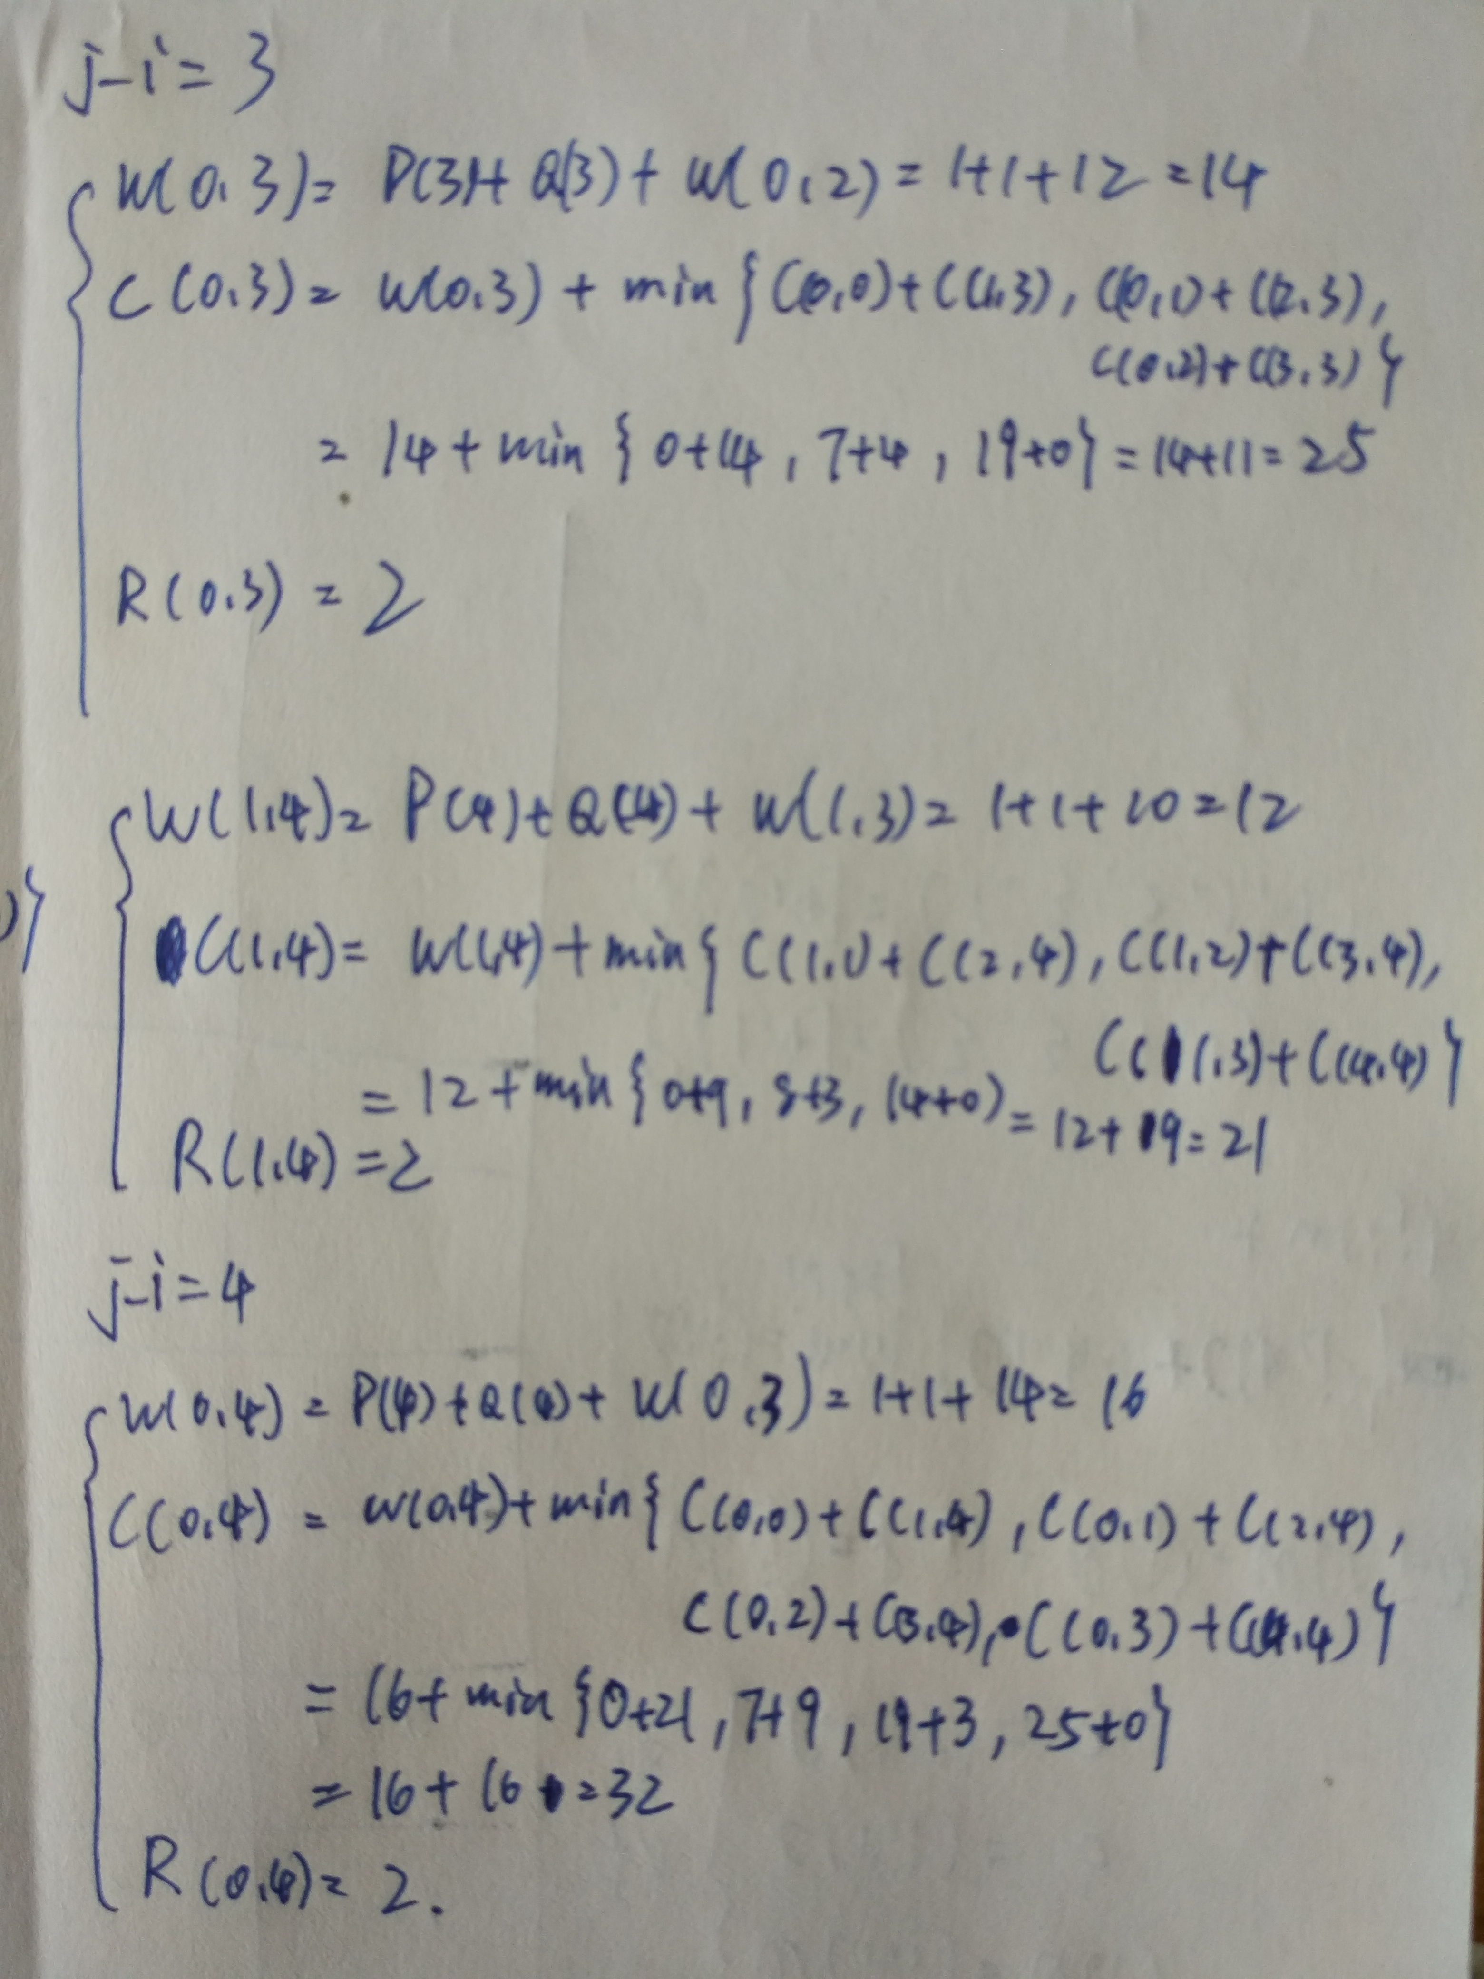

|  |  |  |  |  |  |
| --- | --- | --- | --- | --- | --- |
| j-i i | 0 | 1 | 2 | 3 | 4 |
| 0 | 1,0,0 | 3,0,0 | 2,0,0 | 1,0,0 | 1,0,0 |
| 1 | 7,7,1 | 8,8,2 | 4,4,3 | 3,3,4 |  |
| 2 | 12,19,2 | 10,14,2 | 6,9,3 |  |  |
| 3 | 14,25,2 | 12,21,2 |  |  |  |
| 4 | 16,32,2 |  |  |  |  |

即：

then

stop

do

if